[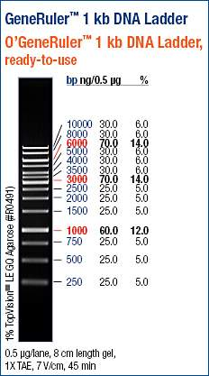](https://www.google.nl/url?sa=i&rct=j&q=&esrc=s&source=images&cd=&cad=rja&uact=8&ved=0CAcQjRxqFQoTCOGTlc3658gCFci9FAodXwwHYw&url=https://www.fishersci.com/shop/products/thermo-scientific-o-generuler-1-kb-dna-ladder-ready-to-use-250-10-000-bp-250-10000bp-0-1-g-l/fersm1163&psig=AFQjCNFZtJwSr0HgqJDyruhEJazt4HyL9w&ust=1446217614881571)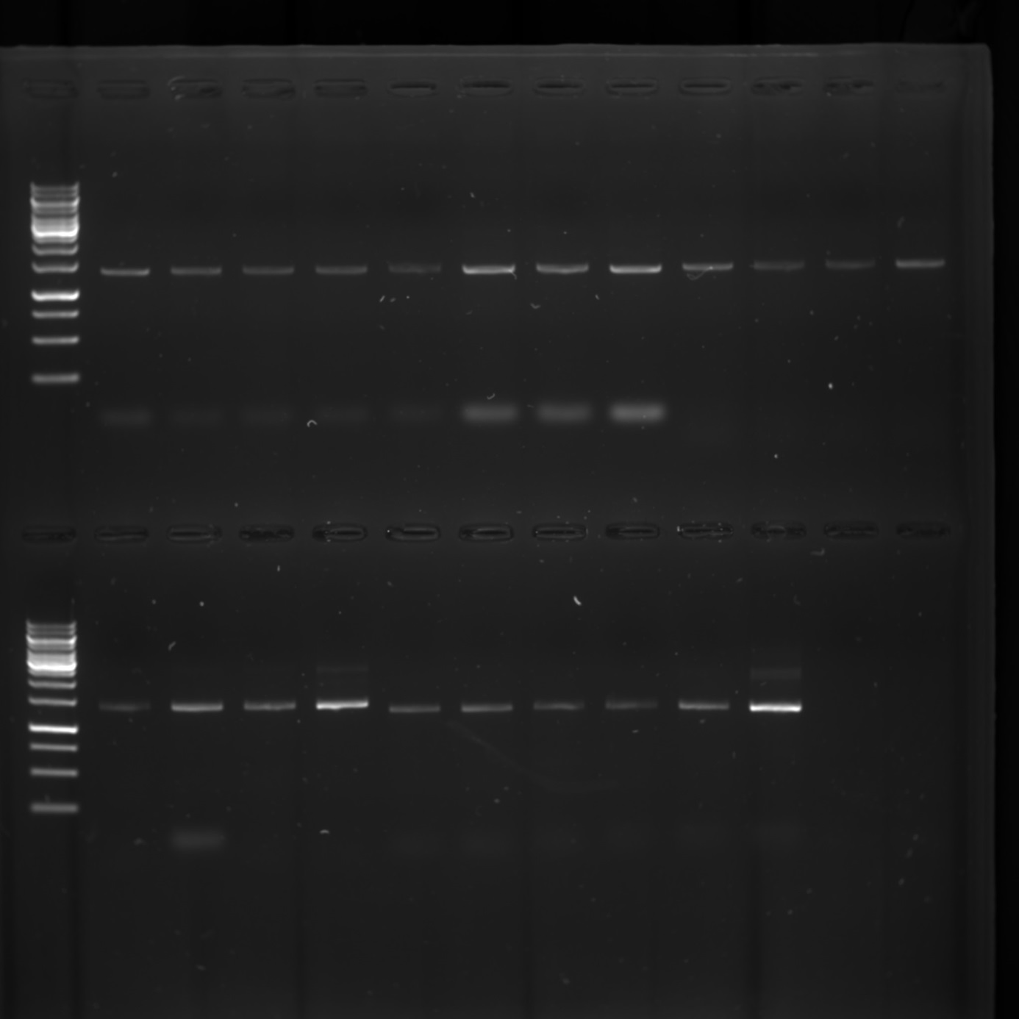

-2.0C - C - +2.0C

- B - +2.0C

-2.0C - B -

M

M

-1.5C - A - +1.5C

**Expected sizes (~)**

**A –** 1332 bp

**B –** 1354 bp

**C –** 1238 bp

**Sample origin**

Apeldoorn Hospital effluent water treated as requested

Phusion® High-Fidelity DNA Polymerase (M0530)

**Reaction Setup**

|  |  |  |
| --- | --- | --- |
| **Component** | **50 µl Reaction** | **Final Concentration** |
| Nuclease-free water | 32.5 µl |  |
| 5X Phusion HF Buffer | 10.0 µl | 1X |
| 10 mM dNTPs | 1.0 µl | 200 µM |
| 10 µM Forward Primer | 2.5 µl | 0.5 µM |
| 10 µM Reverse Primer | 2.5 µl | 0.5 µM |
| Template DNA | 1.0 µl | < 250 ng |
| Phusion DNA  Polymerase | 0.5 µl | 1.0 units/50 µl PCR |

**Thermocycling conditions**

|  |  |  |
| --- | --- | --- |
| **STEP** | **TEMP** | **TIME** |
| Initial Denaturation | 98°C | 30 seconds |
| 35 Cycles | 98°C A – 50 °C  B –  C –  72°C | 10 seconds 30 seconds 30 seconds per kb |
| Final Extension | 72°C | 5-10 minutes |
| Hold | 12°C |  |